Fragments GitHub: https://github.com/MansoorAZafar/fragments
Table of Contents:
- Failing ESLint
- Passing ESLint
- Coverage Report CI 404 handlerr
- Coverage HTML Browser
- CI Failing Test
- CI Passing Test

CI Workflow Failing ESLint
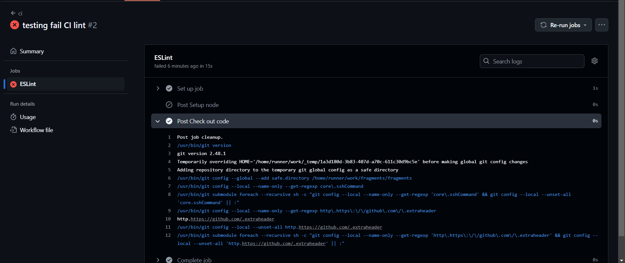
CI Workflow Passing ESLint
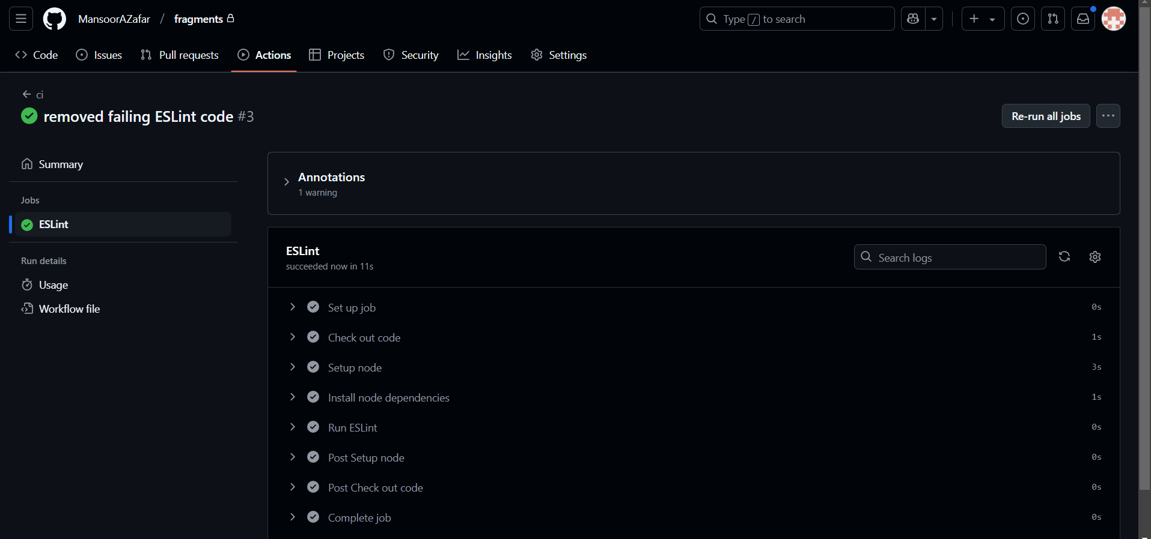
New Coverage after adding 404 Middleware Test
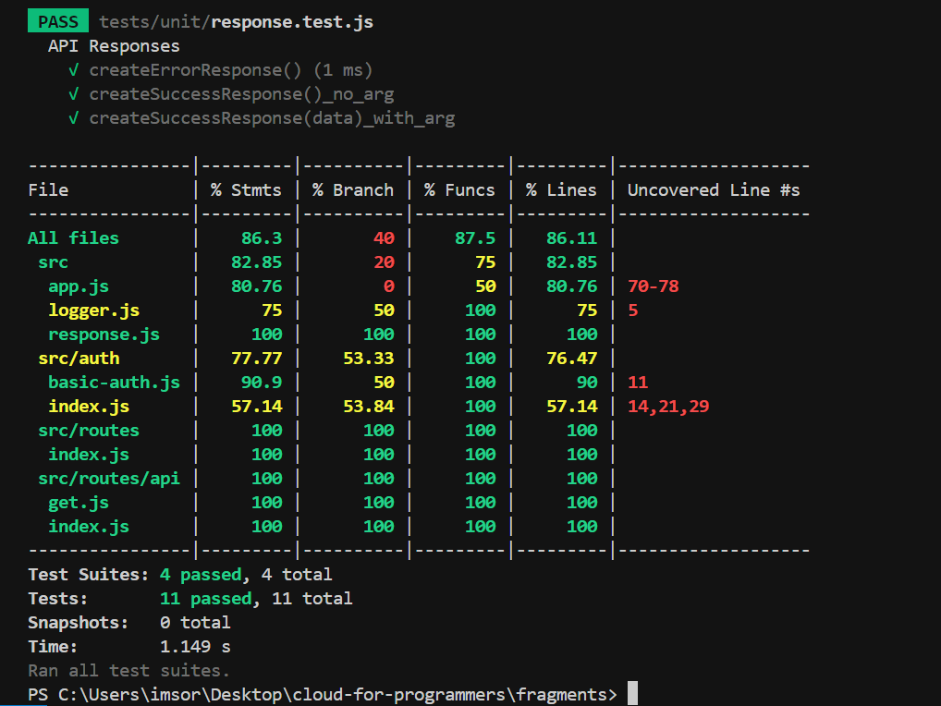
Coverage Report Browser Show (3 images)
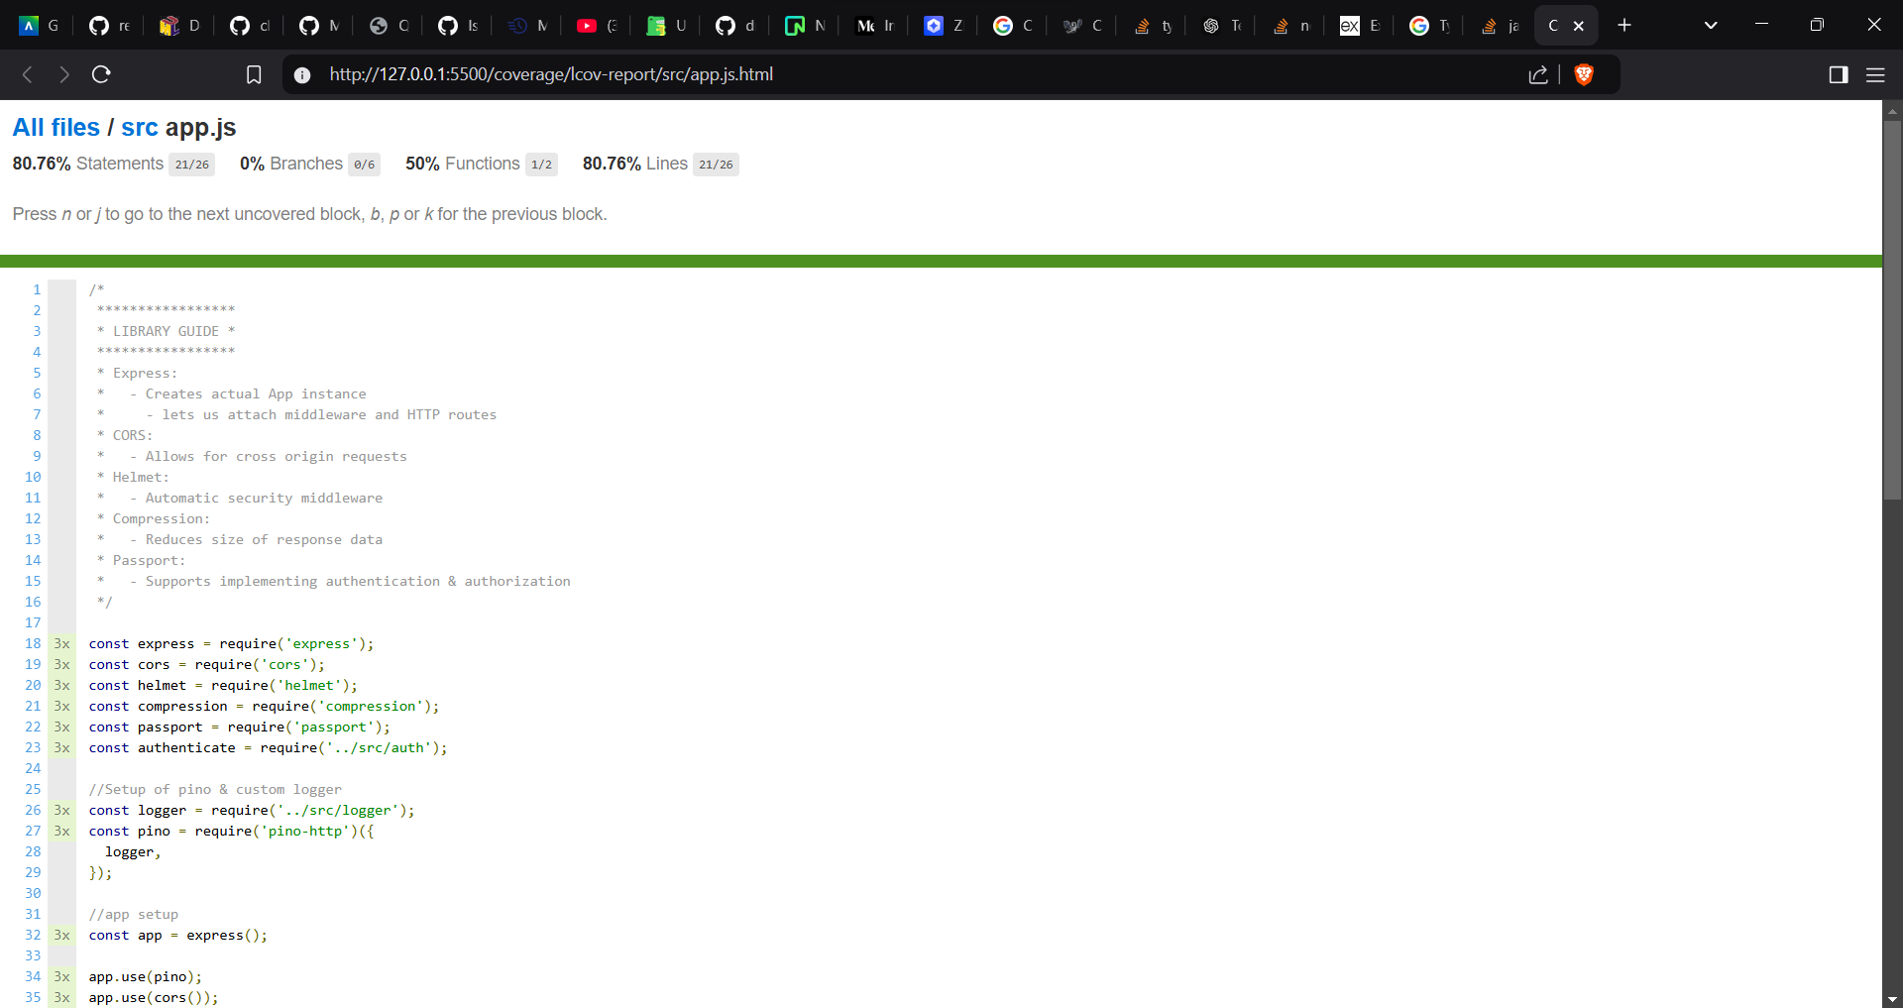
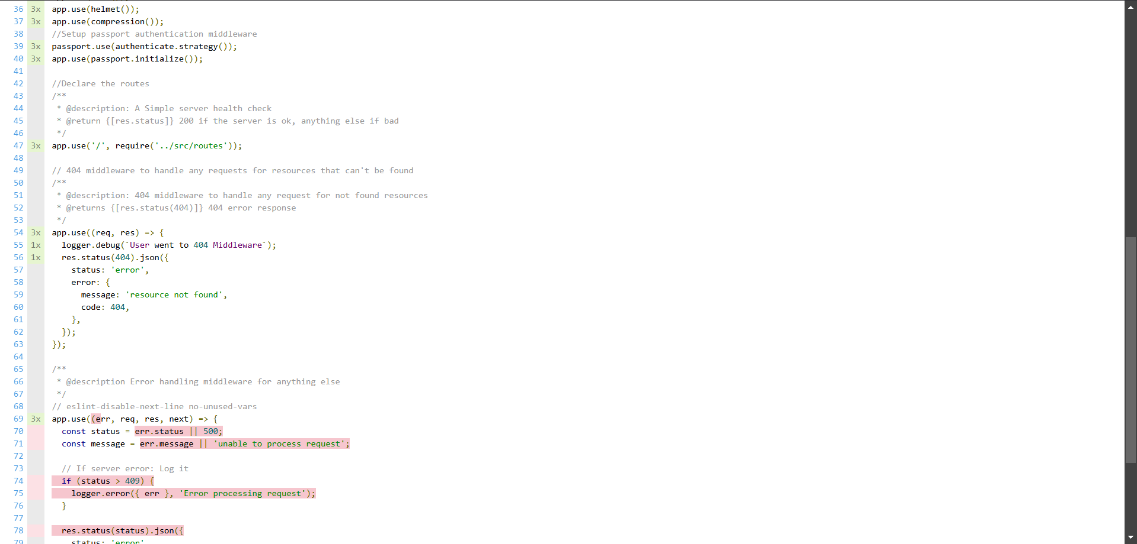
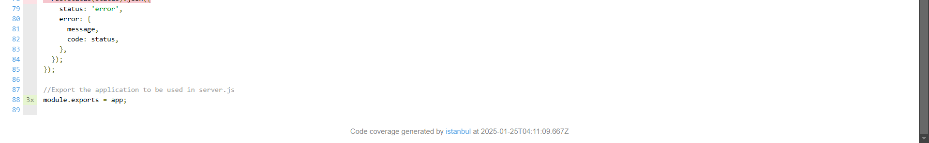

CI Failing Unit Test
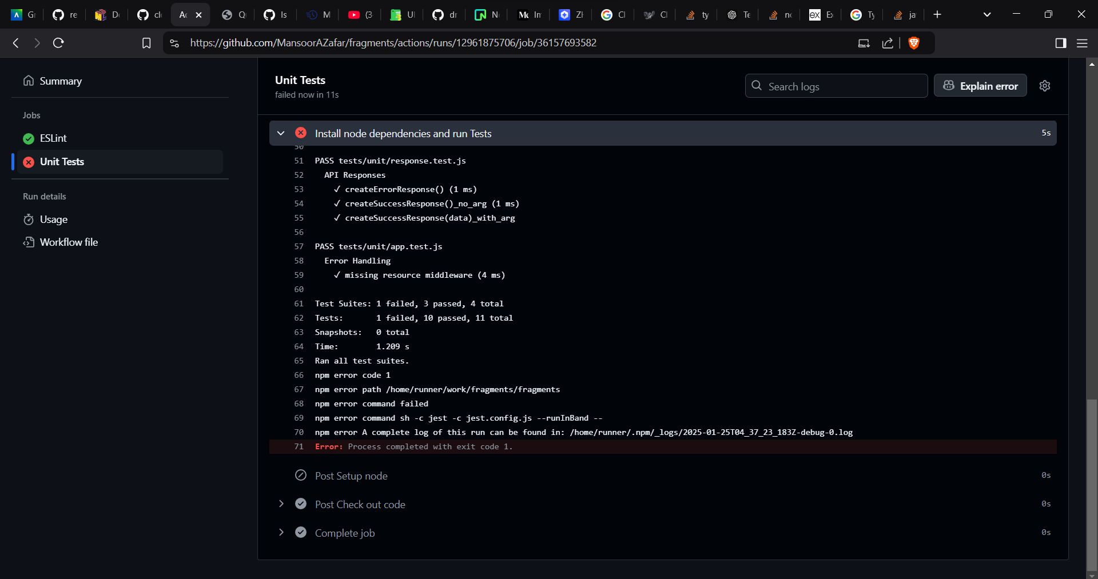
CI Passing Test
